NMRA
Division 10 Board Meeting
January 19, 2022
Members Present:
Bill Robbins
Stew Winstandley
John Gorman
Bob Belt
Larry Smith
Paul Southgate
Randy Coffman

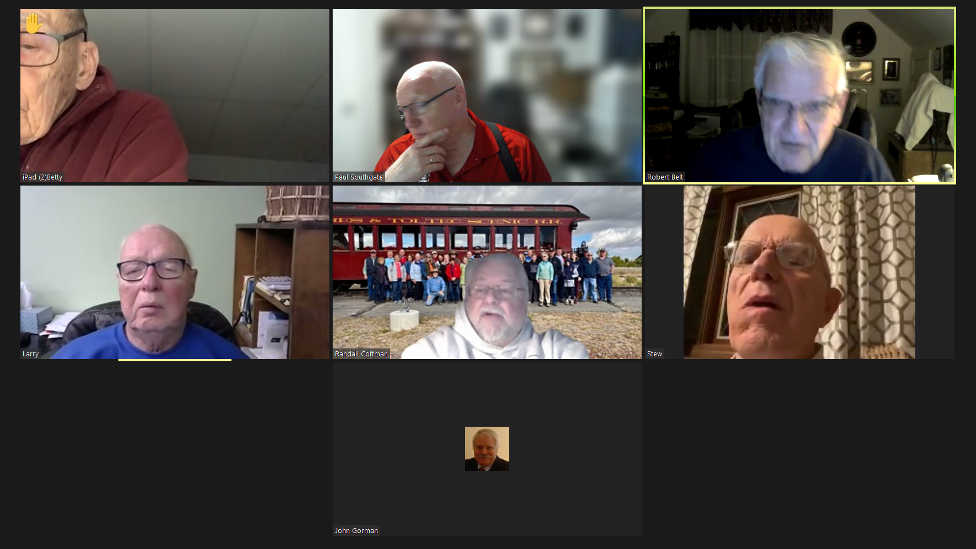

Larry brought the meeting to order for Board of Directors Meeting at 6:46
- Larry Smith submits Bob Belt’s name to fill the balance of Paul Southgate. Motion passed unanimously.
- Lantern which is archived will not include financial information.

Motion to adjourn. Seconded. Passed.

