Building of a CMR T-Trak Module from a Kit. By Richard Hartley
I used a single wide (12”) kit from Custom Models Railroading Products (CMR) to construct this module. There are other kits available from other manufactures such as Masterpiece and Red River.
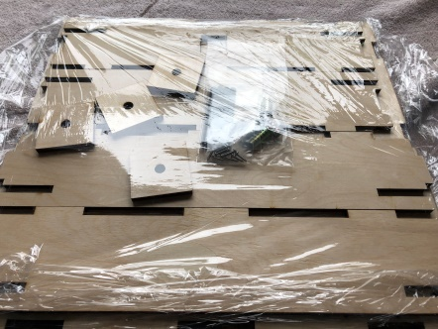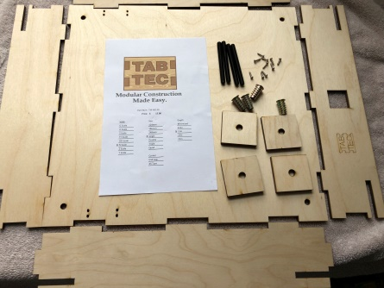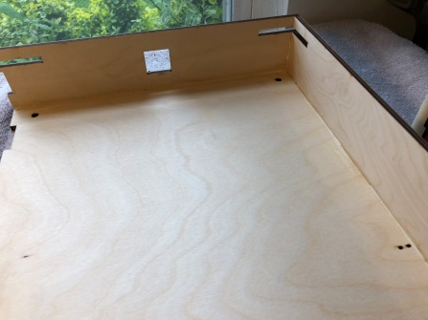
CMR products ships all its modules individually wrapped in plastic. Sort out your basic parts, sides, front, back and top. Glue (I use Titebond) the parts together and use making tape to hold the parts together while the glue dries (you may or may not need the tape).
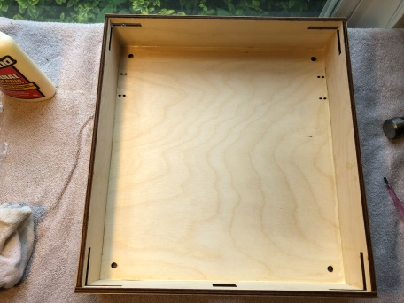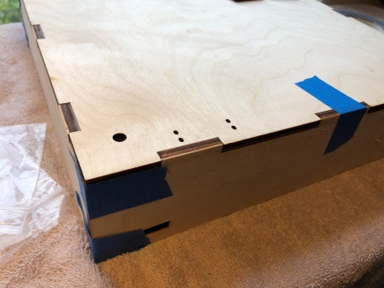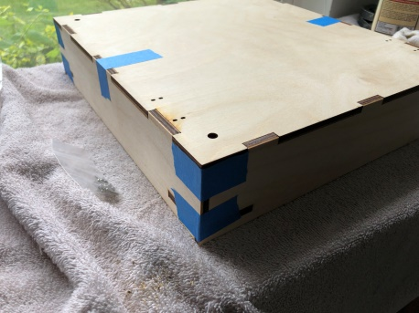

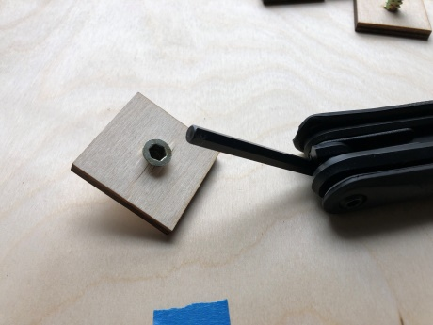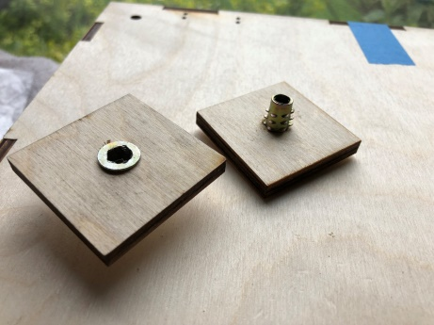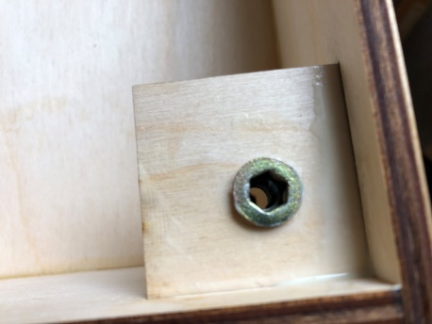
When it comes to mounting of the T bolt is where I hit a snag. The hole is a bit tight and if an allen key (6mm) is used to tighten it you will spilt the wood. I used a 21/64 bit to make the hole bigger (8mm to 8.3mm). After drilling the hole bigger I had no problem seating the T-bolt. Just glue the T-bolt assembly to each corner, checking to make sure you have it pointed in the right direction.

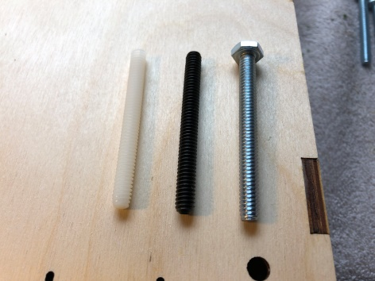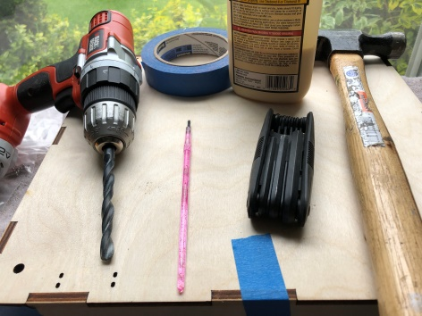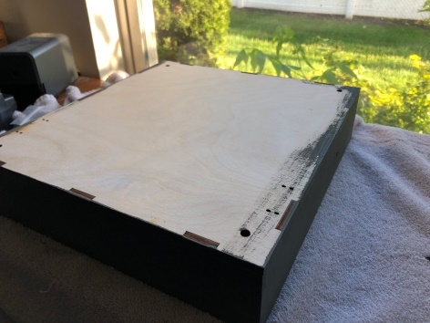
After allowing the glue to dry (I gave it 24 hours) chose which leveling legs you want to use (plastic or metal or hex bolts), paint it the desired color(s) and once the paint dries either use screws (provided in the flush CMR kits) or glue (I use Aleene’s) to attach the track. Remember that if you are going to put a power drop on the module to measure where you are going to attach to the track and drill a ¼” hole. The standard if you want to take the module to another T-Trak event is the outside rails are blue and the inside rails are white. The track to the front of the module is the “red line” the track to the rear of the module is the “yellow line” (TTrak.Wikidot.com will show this in more detail).

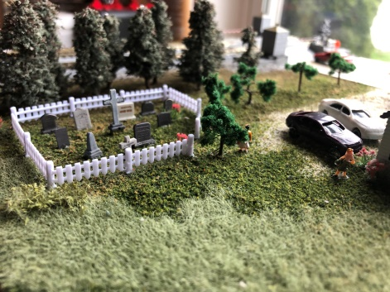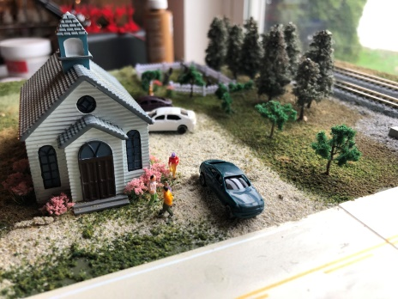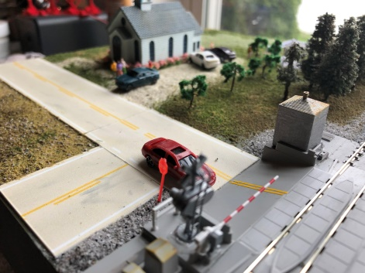

Now all you have to do is scenic and detail the module and run trains.
Links:
• www.cmrproducts.com
• www.T-TRAK.org
• TTrak.Wikidot.com
• T-TRAKHandbook.com

