Building of a T-Trak Module from a Kit. By Richard Hartley
I used a single wide (12”) kit from Masterpiece to construct this module. There are other kits available from other manufactures but I like Masterpiece best.
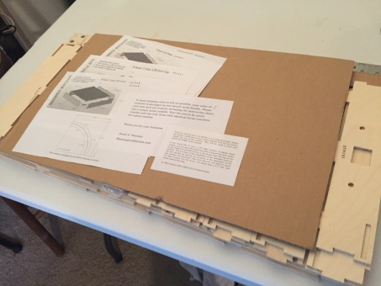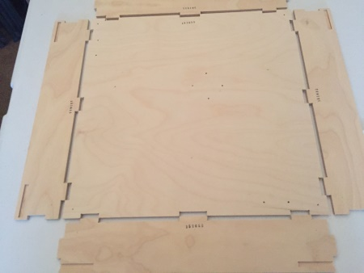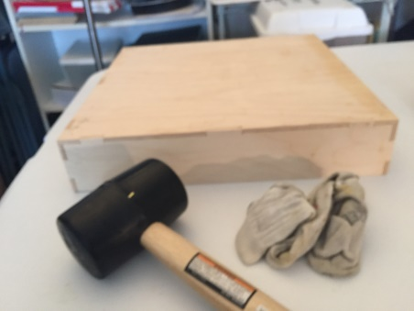
Masterpiece ships all the modules in one package. It’s best to order at least $50 worth of modules to save on shipping. Sort out your basic parts, which have a serial number on each of the sides, front, back and top. Glue (I use Titebond) the parts together and use rubber mallet to seat the parts. Masterpiece has a video on their web site which will help make assembly easier www.masterpiecemodules.com).
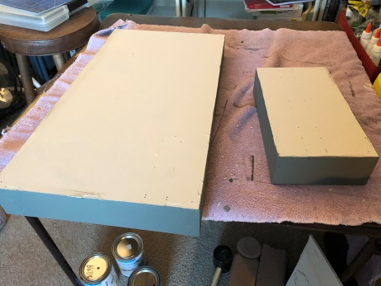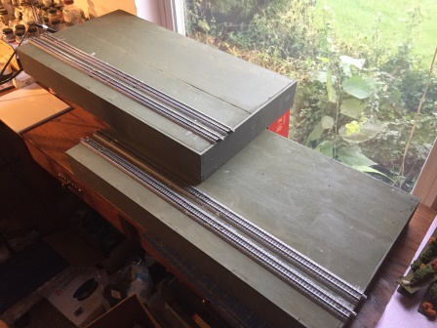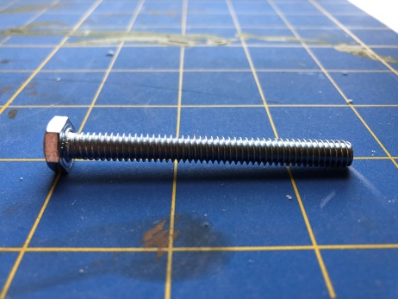
After allowing the glue to dry (I gave it 24 hours) paint it the desired color(s) and once the paint dries either use screws (provided in the flush Masterpiece kits) or glue (I use Aleene’s) to attach the track. Remember that if you are going to put a power drop on the module to measure where you are going to attach to the track and drill a ¼” hole. The standard if you want to take the module to another T-Trak event is the outside rails are blue and the inside rails are white. The track to the front of the module is the “red line” the track to the rear of the module is the “yellow line” (TTrak.Wikidot.com will show this in more detail). I replace the plastic leveling screws with a # 20 ¼”x 2 ½” hex bolt to make it easier to level the module once set up.
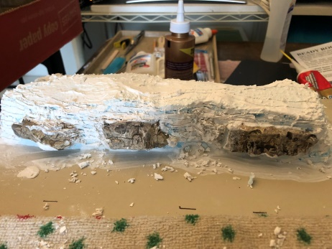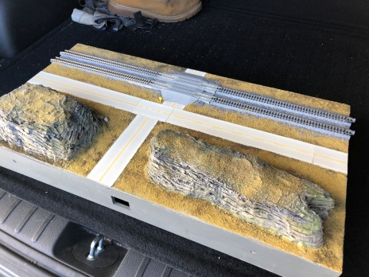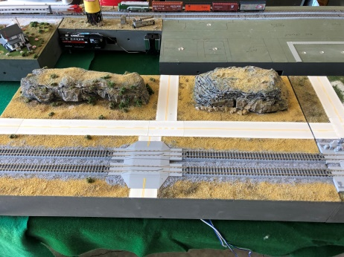
Now all you have to do is scenic and detail the module and run trains. As of this writing Division Six has 8 modules registered for the Regions convention at Boardman in May. (The Bullet 2019) (2 May through 5 May).

